**Practical no.-**7

**Title:** Create a webpage to implement Form Events, Part-I

**Roll No.:** **Batch-** A **Date of Performance:** 03/10/2023

**Code-**

<!DOCTYPE html>

<html>

<head>

<title>Pract 7.2</title>

</head>

<body onload="initializeForm()">

<h1>Onload Form</h1>

<form id="myForm">

<label for="name">Name:</label>

<input type="text" id="name" name="name"><br><br>

<label for="email">Email:</label>

<input type="email" id="email" name="email"><br><br>

<input type="submit" value="Submit">

</form>

<script>

function initializeForm() {

alert("Page is loaded. Form initialized.");

}

</script>

</body>

</html>

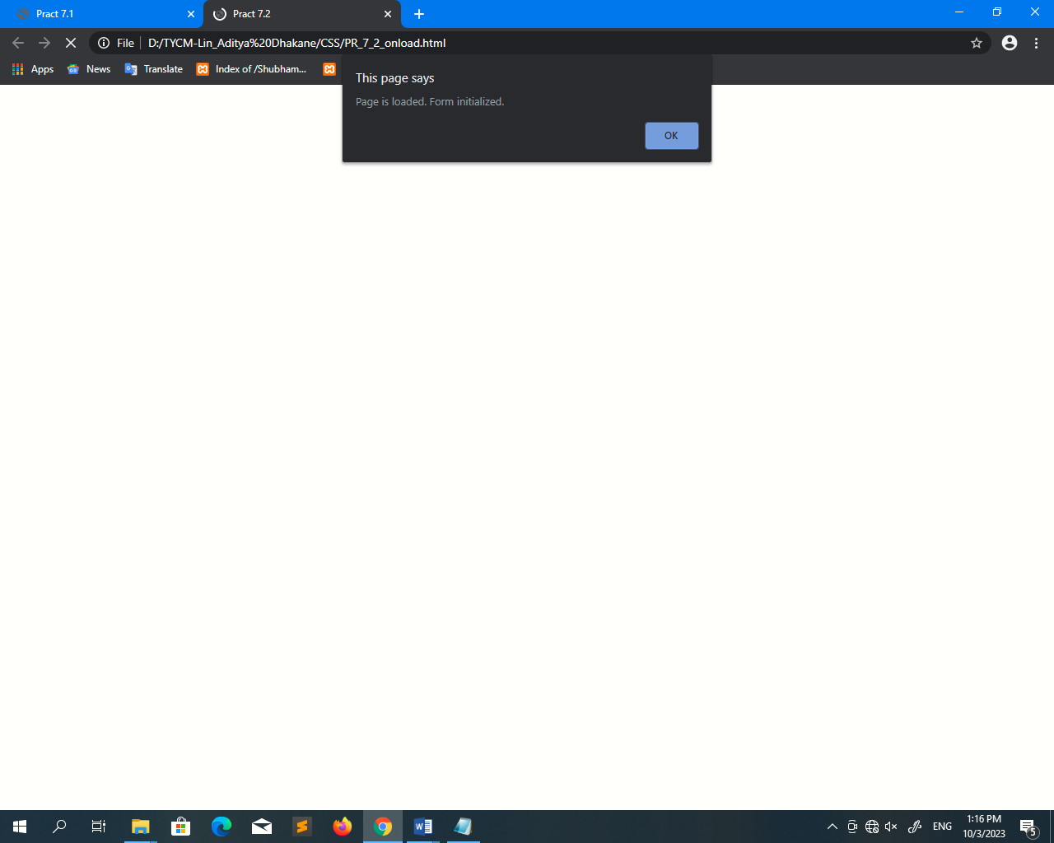**Output-**

